PROG 6212
Boikanyo Maleka
ST10472664
Programming
04 September 2026
Section A

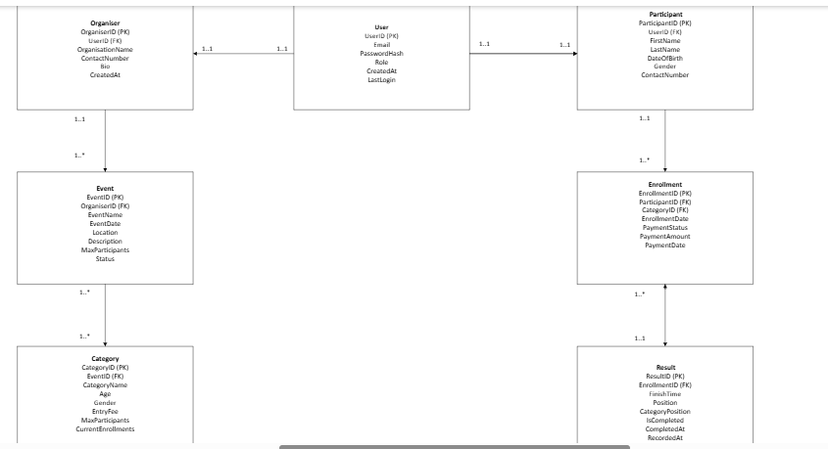

Section B

HTTP Method | Route | Description | Role Required | Request Body | Expected Response
AUTHENTICATION
Post | /api/auth/register | Register a new user account | None (Public) | {email, password, role, firstName, lastName, contactNumber} | 201 Created - User registered successfully
Post | /api/auth/login | Authenticate user and return JWT token | None (Public) | {email, password} | 200 OK - {token, user}
Get | /api/auth/profile | Get current user profile | Any (Logged in) | None | 200 OK - User profile data
USER PROFILE
Get | /api/users/profile | Get authenticated user's full profile | Any (Logged in) | None | 200 OK - User profile with role-specific data
Put | /api/users/profile | Update user profile information | Any (Logged in) | {firstName, lastName, contactNumber, etc.} | 200 OK - Profile updated successfully
Get | /api/users/participants | Get all participants | Organiser, Admin | None | 200 OK - List of participants
ORGANISER
Get | /api/organisers | Get all organisers | Any (Logged in) | None | 200 OK - List of organisers
Get | /api/organisers/my | Get current user's organiser profile | Organiser | None | 200 OK - Organiser profile
EVENTS
Get | /api/events | Get all upcoming events | None (Public) | None | 200 OK – List of events
Get | /api/events/{id} | Get specific event details | None (Public) | None | 200 OK - Event details with categories
Post | /api/events | Create a new event | Organiser | {eventName, eventDate, location, description, maxParticipants} | 201 Created - Event created successfully
Put | /api/events/{id} | Update event details | Organiser(owner) | {eventName, eventDate, location, etc.} | 200 OK - Event updated successfully
Delete | /api/events/{id} | Delete an event | Organiser (owner), Admin | None | 200 OK - Event deleted successfully
Get | /api/organisers/events | Get events organised by current user | Organiser | None | 200 OK - List of user's events
CATEGORIES
Get | /api/events/{eventId}/categories | Get all categories for an event | None (Public) | None | 200 OK - List of categories
Post | /api/events/{eventId}/categories | Add category to event | Organiser (owner) | {categoryName, minAge, maxAge, gender, entryFee, maxParticipants} | 201 Created - Category added successfully
Put | /api/categories/{id} | Update category details | Organiser (owner) | {categoryName, minAge, maxAge, entryFee, etc.} | 200 OK - Category updated successfully
Delete | /api/categories/{id} | Delete a category | Organiser (owner), Admin | None | 200 OK - Category deleted successfully
ENROLLMENTS
Get | /api/participants/enrollments | Get current participant's enrollments | Participant | None | 201 Created - Enrollment successful
Post | /api/events/{eventId}/categories/{categoryId}/enroll | Enroll in an event category | Participant | {emergencyContact, agreeToTerms} | 201 Created - Enrollment successful
Get | /api/enrollments/{id} | Get enrollment details | Participant, Organiser | None | 200 OK - Enrollment details
Put | /api/enrollments/{id} | Update enrollment (payment status) | Participant, Organiser | None | 200 OK - Enrollment updated
Delete | /api/enrollments/{id} | Cancel enrollment | Participant (before event) | None | 200 OK - Enrollment cancelled
Get | /api/events/{eventId}/enrollments | Get all enrollments for an event | Organiser (owner) | None | 200 OK - List of enrollments
Get | /api/categories/{categoryId}/enrollments | Get enrollments for a category | Organiser (owner) | None | 200 OK - List of enrollments
RESULTS
Get | /api/events/{eventId}/results | Get all results for an event | None (Public) | None | 200 OK - List of results
Get | /api/categories/{categoryId}/results | Get results for a category | None (Public) | None | 200 OK - Category results
Post | /api/enrollments/{enrollmentId}/result | Submit result for participant | Organiser (owner) | {finishTime, position, categoryPosition} | 200 OK - Category results
Put | /api/results/{id} | Update result | Organiser (owner), Admin | {finishTime, position, categoryPosition} | 201 Created - Result recorded
Get | /api/participants/results | Get current participant's results | Participant | None | 200 OK – User’s race results
Get | /api/participants/{id}/results | Get participant's all results | Any (Public) | None | 200 OK - Participant's historical results

Section C
